_____________________________ La Mesa-Spring Valley School District
4750 Date Avenue · La Mesa, California 91942 · Telephone: 619/668-5700
Office of the Assistant Superintendent, Human Resources

AFFORDABLE CARE ACT: WHAT YOU NEED TO KNOW
Dear New Employee:
You’ve probably heard about the Affordable Care Act, also called the Health Care Reform law. This letter describes what the Affordable Care Act means to you as a school district employee. Starting January 1, 2014, the law requires most Americans to be covered under a health plan ⎯ whether they get it from an employer, a private insurance company or from the government. This is called the “Individual Mandate.” If you do not have health insurance as of this date, you may have to pay a tax penalty.
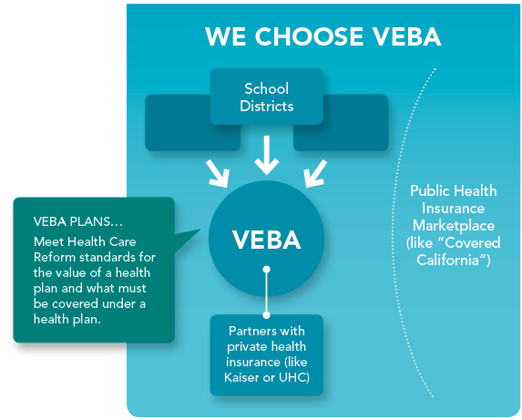
The good news is, if you are eligible for benefits through your school district, your school district benefits through VEBA meet the Individual Mandate requirement. To find out if you are eligible for benefits, contact your school district’s benefits department.
You will probably hear a lot about “exchanges” or “marketplaces.” In California, the public, state-sponsored Health Insurance Marketplace is called Covered CaliforniaTM. This marketplace is intended to help people without coverage find a health plan for 2014. But, if you’re benefits-eligible, you have coverage available through your school district.
There’s a lot we don’t know yet about Covered California. That’s why, for now, we believe the best choice is to offer comprehensive health plan options at the most cost-effective price, directly through VEBA.
We will monitor the changes related to the Affordable Care Act over the coming months and years and continue to use the collective bargaining process for represented employees, as the elements of the law become clearer.
What You Need To Do

The Affordable Care Act makes it clear: it’s up to you to make sure you have health insurance beginning in 2014. If eligible, be sure to enroll in the district health plan that works best for you and your family — so that you’re covered in 2014. If you are not eligible, you may be able to enroll in coverage through your spouse’s/domestic partner’s employer, Covered California (www.coveredca.com), Medicare (if eligible) or Medicaid benefits, if you qualify. (Find out if you are eligible for Medicaid by contacting Medicaid in your state (Medi-Cal in the State of California). Contact information can be found at www.medicaid.gov.)
If you enroll in coverage elsewhere, be sure to review your coverage with your tax planner to ensure your coverage meets the Affordable Care Act requirements.
More information about the Affordable Care Act can be found at www.healthcare.gov, the website sponsored by the Department of Health and Human Services.

