ESS MENU
Fletcher Hills Northmont
Lemon Ave Rolando
Loma Sweetwater Springs
Maryland LMAAC
Murdock Parkway Middle
Murray Manor

Plate Includes 2 of the 4 Components
- Milk, Fluid
- Fruit/Vegetable
- Grains/Breads
- Meat/Meat Alternate

July 2019

MONDAY | TUESDAY | WEDNESDAY | THURSDAY | FRIDAY
1 Nacho Cheese Doritos (1 each)  MILK (8 OZ)  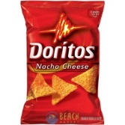 | 2  Cereal (1 Each)  MILK (8 OZ) | 3  Tostitos Scoops (1 Each)  JUICE (6 OZ) | 4 | 5  Whole Grain Pop-Tart (1 Each)  MILK (8 OZ)
8  Cool Ranch Doritos (1 each)  MILK (8 OZ) | 9  Cereal (1 Each)  MILK (8 OZ) | 10 Baked Cheetos (1 Each)  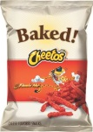  JUICE (6 OZ) | 11  Cheez Its (1 each)  JUICE (6 OZ) | 12 MILK (8 OZ)  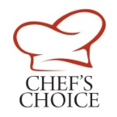
15  Nacho Cheese Doritos (1 each)  MILK (8 OZ) | 16  Cereal (1 Each)  MILK (8 OZ) | 17  Tostitos Scoops (1 Each)  JUICE (6 OZ) | 18  Goldfish Cheddar (1 each)  JUICE (6 OZ) | 19 Whole Grain Pop-Tart  (1 Each) MILK (8 OZ)  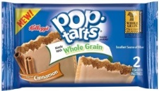
22  Cool Ranch Doritos (1 each)  MILK (8 OZ) | 23  Cereal (1 Each)  MILK (8 OZ) | 24  Baked Cheetos (1 Each)  JUICE (6 OZ) | 25  Cheez Its (1 each)  JUICE (6 OZ) | 26  Chewy Bar (1 each)  MILK (8 OZ)
29  Nacho Cheese Doritos (1 each)  MILK (8 OZ) | 30  Cereal (1 Each)  MILK (8 OZ)  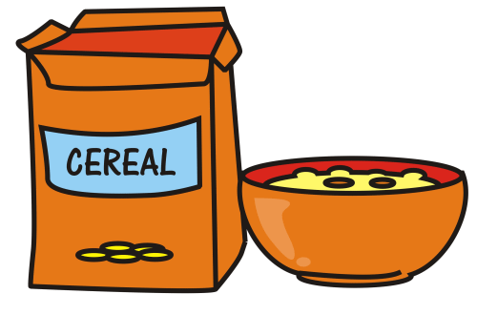 | 31  Tostitos Scoops (1 Each)  JUICE (6 OZ)

Menu subject to change. This institution is an equal opportunity provider.

