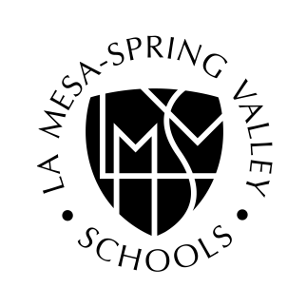

Spring Valley Academy

Academy Enrollment Process

Complete all parts of the packet. Incomplete packets will not be processed.

- Students not currently enrolled in a La Mesa-Spring Valley Schools campus will also need to complete District registration forms upon acceptance into the Academy.

- An Interdistrict transfer will be required upon acceptance of students who do not live within the boundaries of La Mesa-Spring Valley Schools.

- Students who currently attend other LMSVS campus on an Interdistrict transfer will need to resubmit their transfers.

- Students with a 504 Plan must provide a copy of their Plan with this enrollment packet.

- Students with an IEP must provide a copy of their Plan with this enrollment packet. We take pride in the quality programs and services we provide throughout La Mesa-Spring Valley Schools. It is our responsibility to ensure quality and equity of services for students throughout the District and not compromise the quality of our programs or our commitment to excellence.

Should services not be available at the Academy of desired enrollment, services can be provided at another school within our District. The District’s Special Education Department will review the IEP to verify availability of services prior to final approval of a student’s enrollment at an Academy. Enrollment of all students on an IEP is pending approval by the La Mesa-Spring Valley Schools Special Education Department.

- Submit the completed packet and any other necessary documentation in person to:

Spring Valley Academy

3900 Conrad Drive

Spring Valley,CA 91977

- Upon our receipt of the completed packet you will be assigned a lottery number.

La Mesa-Spring Valley Schools is committed to equal opportunity for all individuals in education. The district prohibits discrimination, harassment, intimidation or bullying based on actual or perceived race, color, ancestry, national origin, nationality, ethnic group identification, ethnicity, age, religion, marital or parental status, disability, sex, sexual orientation, gender, gender identity, gender expression or association with a person or group with one or more of these actual or perceived characteristics. Complaints alleging unlawful discrimination may be filed using the district’s Uniform Complaint Procedures. (BP 0410 BP 1312.3)00000000000000

Enrollment Packet
Office use
Date rec’d__________
Time:_______________
Initials:_____________

Lottery #:

M / F
Last name First name Gender Date of birth

Address Apt. # City Zip

Parent/Guardian name Phone Email Address

6th / 7th / 8th
Name of current school Current Grade Circle grade next school year (August 2020)

Siblings that currently attend Spring Valley Academy:
Name: Current grade (this school year):

Siblings that are applying for Spring Valley Academy for next year:
Name: Grade next school year (2020-21):

Does your child have an IEP? ❑ Yes ❑ No
Does your child have a 504 Plan? ❑ Yes ❑ No
A copy of your child’s IEP or 504 Plan must be included with enrollment packet. Enrollment of a student on an IEP requires approval by the Special Education Department.

________________________________________________________________________________________

The above enrollment information is true and accurate to the best of my knowledge.

Parent signature_______________________________________________Date________________________

