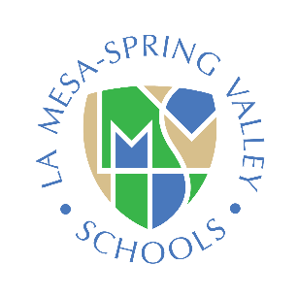
California Department of Education

Williams Complaint Classroom Notice
La Mesa-Spring Valley School District

Notice to Parents, Guardians, Pupils, and Teachers

2020-2021
1. There should be sufficient textbooks and instructional materials. That means each pupil, including English learners, must have a textbook or instructional materials, or both, to use in class and to take home.
2. School facilities must be clean, safe, and maintained in good repair.
3. There should be no teacher vacancies or misassignments. There should be a teacher assigned to each class and not a series of substitutes or other temporary teachers. The teacher should have the proper credential to teach the class, including the certification required to teach English learners if present.
Teacher vacancy means a position to which a single designated certificated employee has not been assigned at the beginning of the year for an entire year or, if the position is for a one-semester course, a position to which a single designated certificated employee has not been assigned at the beginning of a semester for an entire semester.
Misassignment means the placement of a certificated employee in a teaching or services position for which the employee does not hold a legally recognized certificate or credential or the placement of a certificated employee in a teaching or services position that the employee is not otherwise authorized by statute to hold.
4. A complaint form may be obtained at the school office, district office, or downloaded from the school’s Web site.
You may also download a copy of the Sample Williams Complaint Form in English and in other languages from the California Department of Education Web site.

