
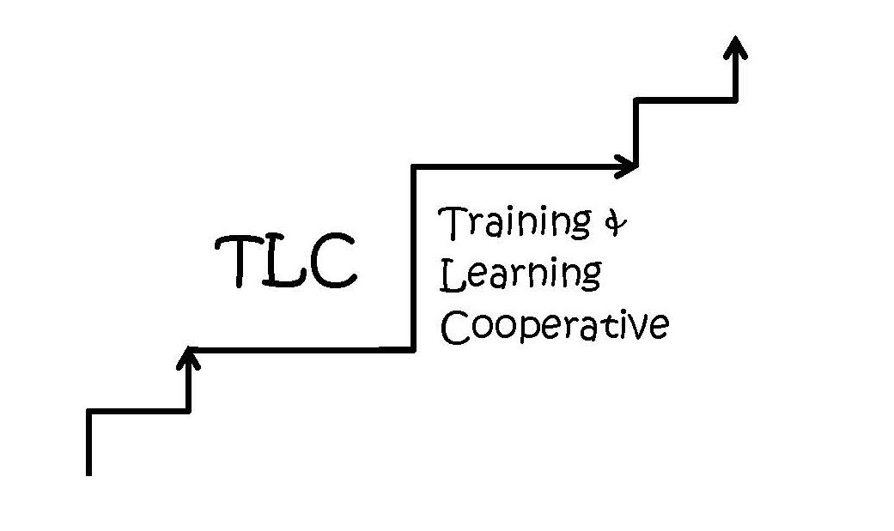
LMSV Training and Learning Cooperative (TLC) Training/Workshop/Class
Funds Application

Name of Applicant
Classification  (Job Title) |  |  |  |  | Your Principal or Supervisor
Mailing Address |  |  |  |  |  |  | Your Preferred Telephone
Training Name
Training Date
Training Provider
Cost of Training |  |  |  | Total Amount Requested
Type of Funds Applied for:
Career Development – learning new skills to qualify for lateral transfers or promotions.
Department Required – needed to meet legal or education code requirements for the job, or to enhance skills relevant to my current job or other related-duties assigned.

Training Description and Need — Describe the need for this training and a summary of what will be learned in one or two sentences summarizing the who, what, where, why, and when.
Evaluation —How will the success of this training be measured?
Training Rationale— Briefly describe how this training will strengthen your ability to do your job. Be specific as to anticipated skills, knowledge and/or professional development.
District Impact — Describe how the requested funds will increase your knowledge and how you will use the information learned. Indicate what the attendee should be able to do at the conclusion of the training or expected beneficial outcomes.

Shared Contribution—Describe any contribution, either cash or “in-kind”, that you or your school or department is making for you to attend this training (e.g., paying for a substitute, sharing the cost, providing transportation or meals).
Scope of Training/Sustainability — Does this training occur regularly or is this a one-time event? If this is a training that requires addition follow-up training, what plans are being made to ensure the participants to attend additional dates?
Training Communication—Describe any plans for sharing the materials/information gained with others in the school district, and specifically with others in the same classification.

I understand that I am required to submit a receipt and an evaluation form within 30 days of completing this training before I will be reimbursed.
Applicant Signature |  | Date
Principal/Supervisor Signature |  | Date

Principal/Supervisor signature required if the class/workshop will interfere with regular working hours.

Remember to supply a copy of the flyer, training brochure or conference information that lists the date, location, cost, and other pertinent information that will support the committee in making its decision.

Starting July1, 2018: CPR and 1st Aid certifications required for current job descriptions must be reimbursed through employee’s department. District/Department required training will not be approved through TLC.

Submit this application, by e-mail or hard copy, to:
LMSV Training and Learning Cooperative (TLC)
Attention: Ali Junker
Human Resources Analyst, Personnel Commission
La Mesa-Spring Valley Schools Education Service Center
Alison.junker@lmsvschools.org

